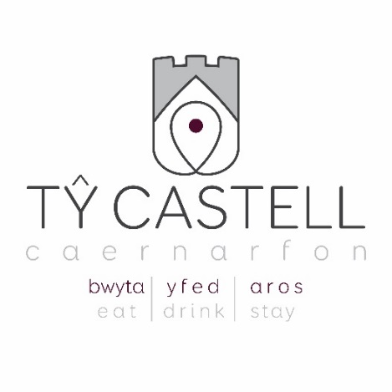

18, Stryd Fawr, Caernarfon 01286 674 937
ty-castell@outlook.com www.tycastell.cymru @TyCastellCaernarfon.cymru

Bwydlen Nadolig 2018

I ddechrau
Cawl Llysiau’r Ddaear Rhost gyda Surdoes

Paté Corbys Coch, Tomato Heulsych a Medd Cymreig

Roulade Paté Hwyaden ac Oren a Seleriac

Cacen Bysgod Hadog wedi’ fygu, Cheddar a Chennin gyda Saws Caws

Prif Gwrs
Paupiette Twrci wedi’ weini gyda Phanas Rhost, Stwnsh Rwdan, Tatws Rhost, Ysgewyll wedi’ carameleiddio a Jus Cyrens Coch

Cig Eidion Rhost Cymreig o ochr orau’r forddwyd (topside) wedi’ weini gyda Phanas Rhost, Stwnsh Rwdan, Tatws Rhost, Ysgewyll wedi’ Carameleiddio, Jus Cyrens Coch a Phwdin Efrog

Deuawd o Ddraenog y Môr ac Eog wedi’ gweini â Risotto Cimwch

Ffalaffel Tatws Melys, Ratatouille, Ysgewyll wedi’ carameleiddio a Phanas Rhost

Pwdin
Pwdin Nadolig traddodiadol gyda Hufen Brandi
Mousse Siocled gyda Bisged Brau, Siard Siocled a Ffrwythau wedi’ malu
Tiramisù
Cacen Gaws Taffi ac Afal gyda Saws Caramel

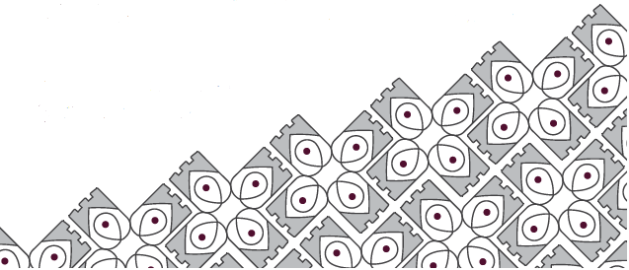

Pris: 2 gwrs - £19.50 3 cwrs – £24.50

*Am wybodaeth alergenau, holwch os gwelwch yn dda

18, Stryd Fawr, Caernarfon 01286 674 937
ty-castell@outlook.com www.tycastell.cymru @TyCastellCaernarfon.cymru

Christmas Menu 2018

Starters
Roast Root Vegetable Soup with Sourdough

Red Lentil, Sundried Tomato and Welsh Mead Paté

Duck and Orange Paté and Celeriac Roulade

Smoked Haddock, Cheddar and Leek Fishcake with Cheese Sauce

Main Course
Turkey Paupiette served with Roasted Parsnip, Stwnsh Rwdan, Roast Potatoes, Caramelised Sprouts and Redcurrant Jus

Roast Welsh Topside of Beef served with Roasted Parsnip, Stwnsh Rwdan, Roast Potatoes, Caramelised Sprouts and Redcurrant Jus and Yorkshire pudding

Duo of Seabass and Salmon served with Lobster Risotto

Sweet Potato Falafel, Ratatouille, Caramelised Sprouts and Roasted Parsnip

Dessert
Traditional Christmas pudding with Brandy Cream
Chocolate Mousse, Shortbread, Chocolate Shard and Macerated Fruit
Tiramisu
Toffee and Apple Cheesecake with Caramel Sauce

Price: 2 course - £19:50 3 course – £24:50

*For allergen information please enquire

18, Stryd Fawr, Caernarfon 01286 674 937
ty-castell@outlook.com www.tycastell.cymru @TyCastellCaernarfon.Cymru

Bwydlen Tapas Nadolig 2018

O’r Tir
Moch Bach mewn Mêl a Hadau Sesame £6.50
Peli Cig Twrci a Chorizo gyda Gwin Cynnes a Siytni Gellyg £7.00
Sleisys o Frest Hwyaden wedi’ mygu gyda Bresych Coch a Cheirios y Tymor Diwethaf £9.00
Tagine o Gig Oen Cymreig, Bricyll a Gwygbys (chickpeas) £9.00

O’r Môr
Cacen Bysgod Hadog wedi’ Fygu, Cennin a Chaws £6.50
Gravlax Eog, Sinsir wedi’ Biclo a Mayonnaise Wasabi £7.00
‘Coctêl Corgimwch’ Tŷ Castell, Dail Letysen Gem wedi’ llosgi a Mari Waedlyd £8.00
Filed Penfras, Ffâ Menyn, Hadau wedi’ Tostio, Dresin Soy a Lemwnwellt
gyda Thameidiau o Gytew Licoris £8.50

O’r Groser
Ponsh Maip gydag Wy Hwyaden wedi’ Botsio £6.50
Falafel Tatws Melys gyda Ratatouille £7.00
Camembert Cyfan, Saws Llugeuron a Surdoes Crimp £9.00
Tatws Melys wedi’ Rhostio mewn Lemwn a Theim, Spaghetti, Hufen Cnau Pîn wedi’ Tostio
a Saets Crimp £6.50

Ar yr ochr am £4.00 yr un: Ysgewyll wedi’ Rhostio gyda Lardons wedi’ Mygu; Llysiau Daear y Gaeaf Rhost; Bresych Coch wedi’ Carameleiddio; Tatws Rhost

Rhywbeth Melys
Pwdin Nadolig Traddodiadol gyda Hufen Brandi £7.00
Mousse Siocled gyda Bisged Brau, Siard Siocled a Ffrwythau wedi’ malu £7.00
Cacen Gaws Taffi ac Afal gyda Saws Caramel £7.00
Tiramisù £7.00

18, Stryd Fawr, Caernarfon 01286 674 937
ty-castell@outlook.com www.tycastell.cymru @TyCastellCaernarfon.Cymru

Christmas Tapas Menu 2018

From the Land
Pigs in Blankets with Honey and Sesame Seeds £6.50
Turkey and Chorizo Meatballs with Mulled Wine and Pear Chutney £7.00
Slices of Smoked Duck Breast with Red Cabbage and Last Season’s Cherries £9.00
Tagine of Welsh Lamb, Apricots and Chickpeas £9.00

From the Sea
Smoked Haddock, Leek and Cheese Fish Cake £6.50
Salmon Gravlax, Pickled Ginger and Wasabi Mayonnaise £7.00
Tŷ Castell ‘Prawn Cocktail’, Charred Gem Hearts, Bloody Mary £8.00
Cod Fillet, Butter Beans, Toasted Seeds, Soy and Lemongrass Dressing
with Liquorish Batter Bits £8.50

From the Grocer
Bubble and Squeak with Poached Duck’s Egg £6.50
Sweet Potato Falafel with Ratatouille £7.00
Whole Camembert, Cranberry Sauce, Crisp Sour Dough £9.00
Lemon and Thyme Roasted Sweet Potato, Spaghetti, Toasted Pine nut Cream and
Crispy Sage £6.50

Sides at £4.00 each: Roasted Sprouts with Smoked Lardons; Roasted Winter Root Vegetables; Caramelised Red Cabbage; Roast Potatoes

Something Sweet
Traditional Christmas pudding with Brandy Cream £7.00
Chocolate Mousse, Shortbread, Chocolate Shard and Macerated Fruit £7.00
Toffee and Apple Cheesecake with Caramel Sauce £7.00
Tiramisù £7.00

